


Evaluation du module
ASP.NET et ADO.NET

Partie 1 : QCM

Le QCM est découpé en deux (2) parties.

La première partie est composé de 30 questions à choix multiples numérotées de 1 à 30. Les questions peuvent avoir différentes formes :
• Code à trous
• Choix unique
• Choix multiples
• Semi-ouvertes/Ouvertes

La seconde partie est une étude de cas et demande une analyse plus poussée du sujet, elle comporte 8 questions numérotées de A à H.

Les questions portent toutes sur cette même étude et ont les mêmes formes que les questions de la première partie.

Toutes les questions sont en ANGLAIS.

Score :

Les questions à choix unique et à choix multiples de la première partie valent toutes un (1) point par réponse juste, une réponse fausse vaut zéro (0) point.
Les codes à trous valent un (1) point PAR trous correctement rempli, zéro (0) point sinon. Les questions semi-ouvertes/ouvertes ont un score particulier et dépendant du choix ET de
l’ordonnancement des réponses selon les cas.

Il est possible pour les choix multiples d’obtenir partiellement le score de la question.

La deuxième partie utilise le même système de point mais les résultats sont doublés (coefficient 2).

Le total de l’examen est sur 104 points.

Durée :

2H

You develop an ASP.NET MVC application that includes the following class. Line numbers are included for reference only.

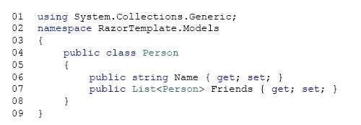
You must use the Razor view engine to display all property values for the class. You need to implement the view.

How should you complete the relevant code? To answer, select the appropriate code segment from each list in
the answer area.

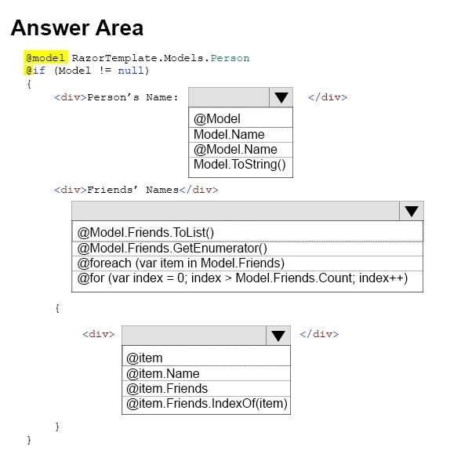

You need to ensure that URLs for log manipulation are mapped to the controller. You have the following code:

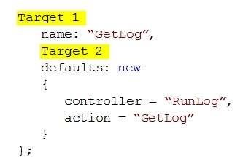
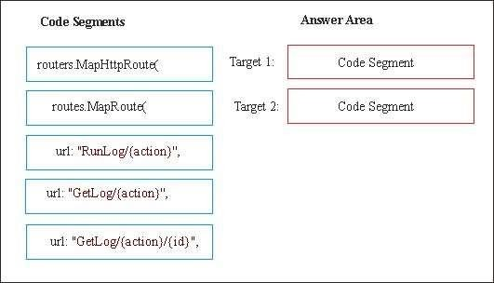Which code segments should you include in Target 1 and Target 2 to map the URLs? To answer, drag the appropriate code segments to the correct targets. Each code segment may be used once, more than once, or not at all.
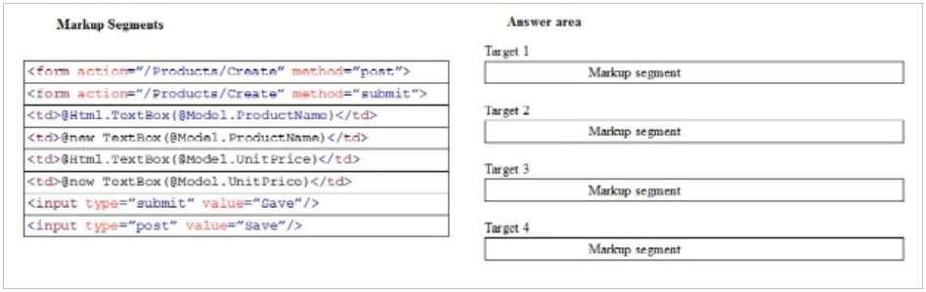

You are developing an ASP.NET MVC web application.
You need to create a form that can be used to add new products to the web application. You have the following markup:

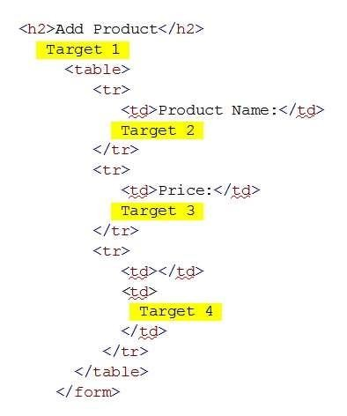Which markup segments should you include in Target 1, Target 2, Target 3 and Target 4 to complete the markup? To answer, drag the appropriate markup segments to the correct targets. Each markup segment may
be used once, more than once, or not at all.

You are developing an ASP.NET MVC application to display product information. The application has two views. The first view displays a list of product names. When you select a product name, the second view shows
detailed information for the product that is selected. The product detail view receives a query string value that contains as identifier for the product that is selected.
The product controller for the application has the following requirements: The product list and product details must use output caching.
The list of products must be cached daily.
The product details view must cache data for one hour, based on the product that is selected. You need to implement the product controller.
How should you complete the relevant code? To answer, select the appropriate code from each list in the answer area.

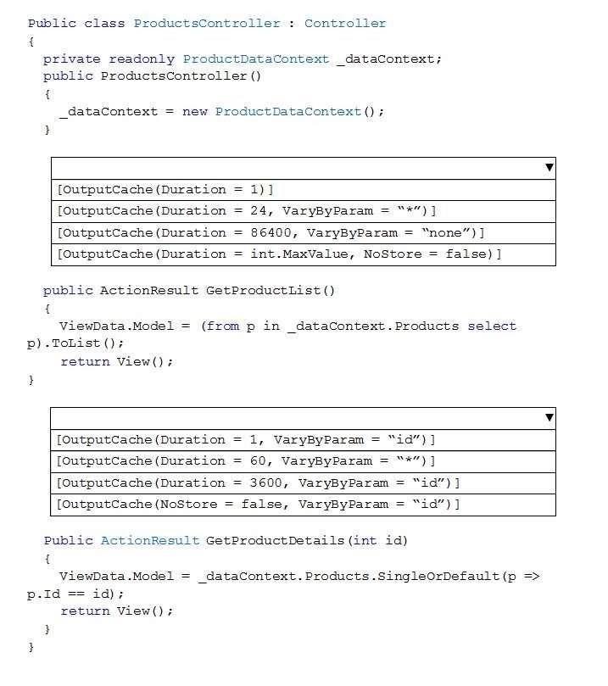
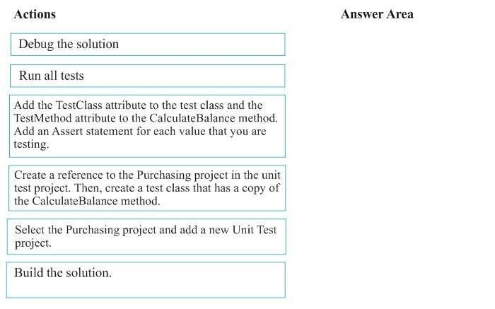

You are building an ASP.NET application for a purchasing system.
The application has a method named CalculateBalance in the Purchasing class. You need to create a unit test for the CalculateBalance method.
Which five actions should you perform in sequence? To answer, move the appropriate actions from the list of actions to the answer area and arrange them in the correct order.
Select and Place:

Your Answer :
Question 6 (6 points) :

You plan a new ASP. NET MVC application.
The application uses the Model-View Controller (MVC) pattern to separate the modeling of the domain, the presentation, and the actions. This separation is based on user input into three separate classes.
You need to diagram the structural relationship between the three classes.What should you do? To answer, drag the appropriate class to the correct location or locations. Each class
name may be used once, more than once, or not at all. You may need to drag the split bar between panes or scroll to view content.
Select and Place:

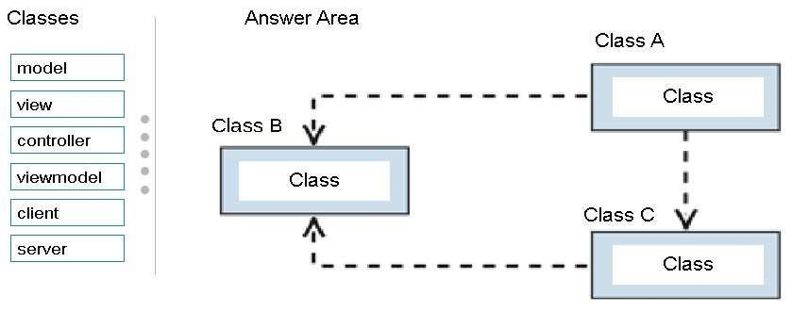In addition, please describe interactions between components by a word or a small sentence.

You are developing an ASP.NET MVC application that delivers real-time game results to sports fans. The application includes the following code. Line numbers are included for reference only.

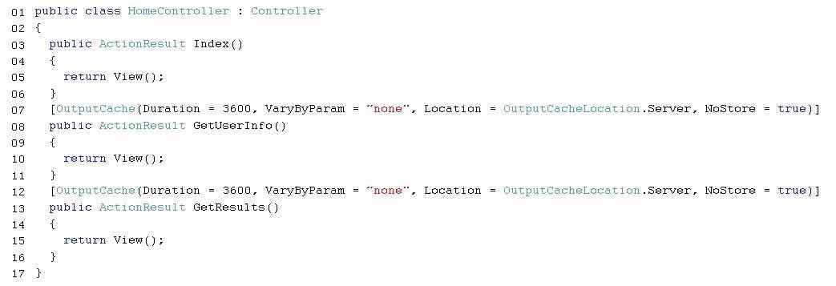

The source data for the game results is updated every 30 seconds. Testers report the following issues with the application:
They report seeing other user’s name when they sign in to the application.
They report delays in seeing the latest game results. You need to correct the performance issues.
Which two changes should you make to the code? Each correct answer presents part of the solution.

A.
Replace the code at line 07 with the following codesegment:[OutputCache(Duration = 30, VaryByParam =
“none”, Location = OutputCacheLocation.Client, NoStore = true)]

B.
Replace the code at line 12 with the following code segment:[OutputCache(Duration = 30, VaryByParam =
“none”, Location = OutputCacheLocation.Server, NoStore = true)]

C.
Replace the code at line 07 with the following code segment:[OutputCache(Duration = 3600, VaryByParam
= “none”, Location = OutputCacheLocation.Server, NoStore = false)]

D.
Replace the code at line 12 with the following code segment:[OutputCache(Duration = 3600, VaryByParam
= “none”, Location = OutputCacheLocation.Client, NoStore = true)]

You are building an ASP.NET web application.
You must test the web application in multiple browsers at the same time. You need to ensure that the application can use the Browser Link feature.
Which two actions should you perform? Each correct answer presents part of the solution.

A.
In the web.config file, set the value of the debug attribute to False.

B.
In the web.config file, set the value of the debug attribute to True.

C.
Enable Browser link.

D.
Use an external editor for webpages.

E.
Enable source control server support.

Question 9 (1 point) :

You are developing an ASP.NET MVC application that uses forms authentication. The application uses SQL
queries that display customer order data.
You need to prevent all SQL injection attacks against the application. How should you secure the queries?

A.
Implement parameterization.

B.
Pattern check the input.

C.
Filter out prohibited words in the input.

D.
Escape single quotes on string-based input parameters.

You are developing an ASP.NET MVC 4 application that includes the following class. Line numbers are included for reference only.

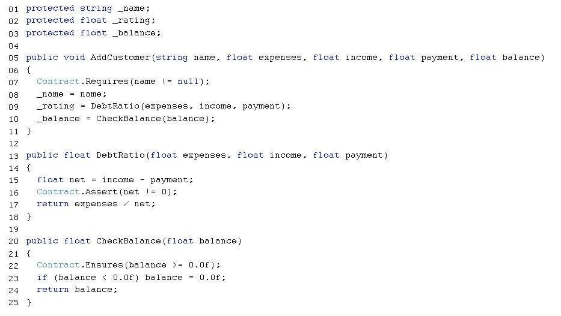

For each of the following statements, select Yes if the statement is true. Otherwise, select No.

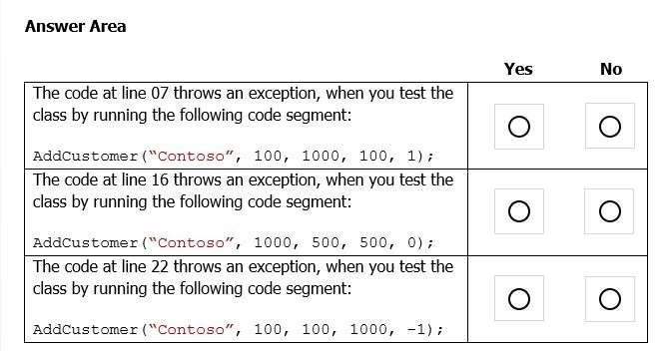

You are developing an ASP.NET MVC application that uses forms authentication. The user database contains
a user named OrderAdmin.
You have the following requirements:
You must allow all users to access the GetOrders method.
You must restrict access to the EditOrder method to the user named OrderAdmin. You need to implement the controller to meet the requirements.
Which code segment should you use? (Each correct answer presents a complete solution. Choose all that apply.)

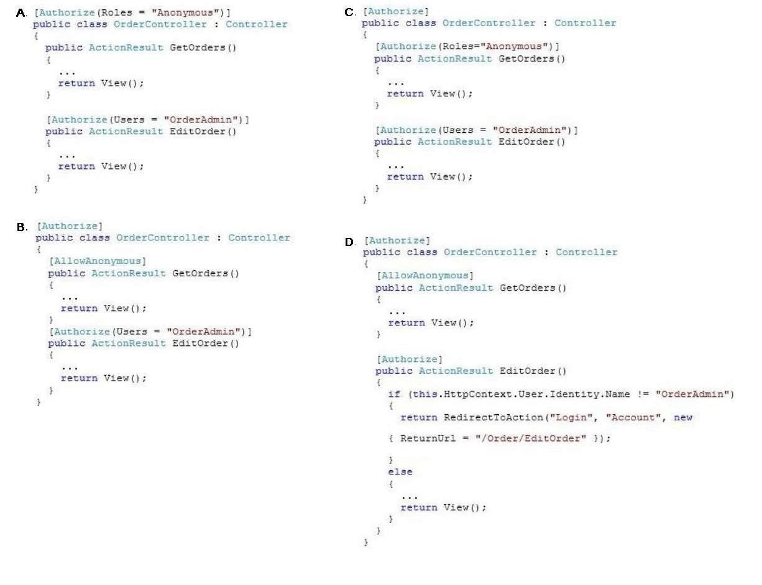

You develop an ASP.NET MVC application. The application includes a feature that allows users to reset their passwords. The feature is enabled by a ForgotPassword controller method and a corresponding Razor view. You need to prevent Cross-Site Request Forgery (CSRF) attacks.
How should you complete the relevant code? To answer, select the appropriate code segment from each list
in
the answer area.

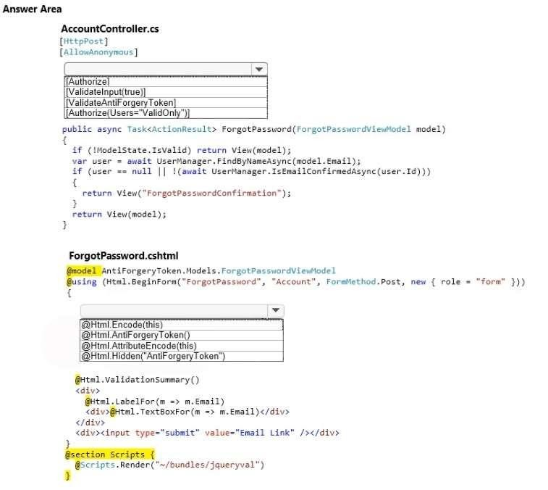
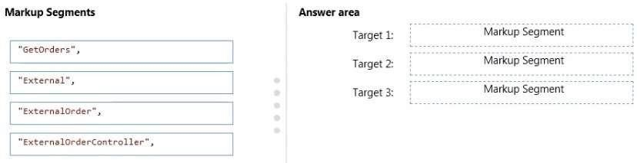

You are developing an ASP.NET MVC application in Visual Studio.
The application contains an area that is defined as shown in the following graphic.

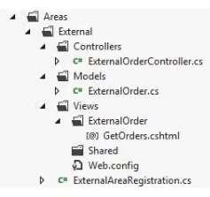

The ActionLink method must invoke the GetOrders() action in ExternalOrderController. You need to configure the parameters of the ActionLink method.
You have the following markup.

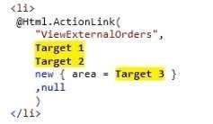

Which markup segments should you include in Target 1, Target 2 and Target 3 to complete the markup? To answer, drag the appropriate markup segment to the correct targets. Each markup segment may be used once,
more than once, or not at all. You may need to drag the split bar between panes or scroll to view content. Select and Place:

You are developing an ASP.NET MVC application.
Before an action is executed, information about the action must be written to a log. After results are returned, information about the results also must be written to the log.
You need to log the actions and results. You have the following code:

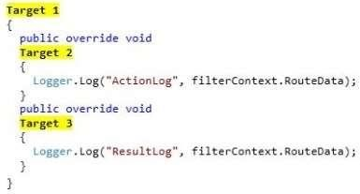

Which code segments should you include in Target 1, Target 2 and Target 3 to implement the LogActionFilter class? (To answer, select the appropriate option from the drop-down list in the answer area.)

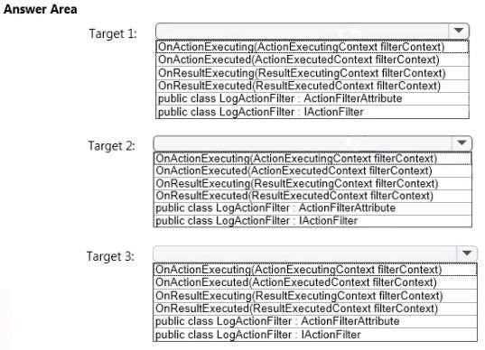

You are developing an ASP.NET MVC application. The application includes the following code.

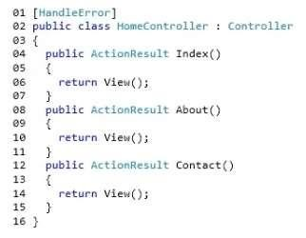
Line numbers are included for reference only.

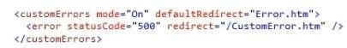

You add the following markup to the system.web section of the web.config file:
For each of the following statements, select Yes if the statement is true. Otherwise, select No.

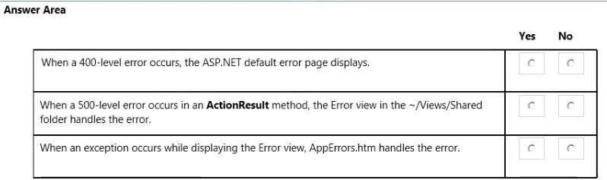

You develop an ASP.NET MVC application. The application has a controller named PeopleController.cs. The controller has an action method that returns a parent view. The parent view includes the following code. Line numbers are included for the reference only.

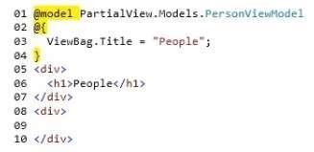

The application also contains a partial view named People. The parent view must display the partial view. You need to add code at line 09 to display the partial view within the parent view.
Which two code segments will achieve the goal? Each correct answer presents a complete solution.

A.
@{ Html.RenderPartial(“People”, Model);}

B.
@Html.Partial(“People”, Model)

C.
@Html.Display(“People”, Model)

D.
@Html.Raw(“People”)

You are developing an ASP.NET MVC application in Visual Studio. The application processes data for a bakery and contains a controller named BagelController.es that has several actions. The GetBagel action is defined in the following code segment.

public �ctionResult Get6agel(string bagelName)
{

}

The GetBagel action is the only action that should be accessed via a URL pattern. Routes to the other actions in the controller must be suppressed.
The default route must map to HomeController and the Index action. You need to build the routes.
Which three code segments should you use in sequence? (To answer, move the appropriate actions from the list of actions to the answer area and arrange them in the correct order.)
Select and Place:

Actions

routes .�lapRoute (
na111e: "Bagels",
ur1: "Bagel/Ge tBagel/ { bagel1,6llle} •,

defaults: new { controller a "Bagel", action a•
GetBage l" }} ;

routes.IgnoreRoute{"Bagel/{4}");

routes.IgnoreRoute("Bagel/{�pathlnfo}");

routes .HapRoute(
name: "Default", url: "{controller}/{ect!on}/
{id}",

defaults: new (controller• "H09e", ection • "I
ndex", id: �rlPara•eter.Optional });

routes.HapHttpRoute{
nam�: ••ea�ls!",
routeTemplate: "B;igel/GetBagel/ {bilgelNome}",

defaults: new {controller• "Bagel", action••
6etB11gel" });
Answer Area

You are building an ASP.NET MVC web application.
The application will be viewed by users on their mobile phones.
You need to ensure that the page fits within the horizontal width of the device screens. You have the following markup:

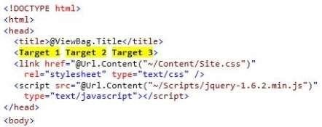

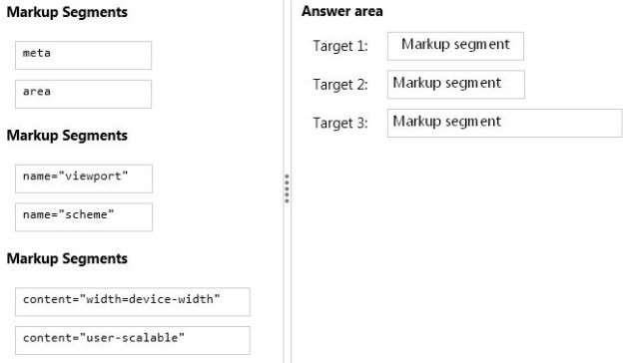Which markup segments should you include in Target 1, Target 2 and Target 3 to complete the markup? (To answer, drag the appropriate markup segments to the correct targets. Each line of code may be used once, more than once, or not at all. You may need to drag the split bar between panes or scroll to view content.) Select and Place:

You are developing an ASP.NET MVC application that uses forms authentication to verify that the user is logged in.
Authentication credentials must be encrypted and secure so no user identity is exposed. You need to ensure that user credentials are persisted after users log on.
Where should you store the credentials? (Each correct answer presents a complete solution. Choose all that
apply.)

A.
In Session on the server

B.
In a cookie stored in the browser

C.
In ViewData in the application

D.
In TempData on the server

Question 20 (3 points) :

You are designing a data-oriented application that features a variety of storage schemas. The application object model must be mapped to the various storage schemas.
You need to enable developers to manipulate the data.
Which ADO.NET data access strategy should you use? (Each correct answer presents a complete solution. Choose all that apply.)

A.
LINQ to SQL

B.
Entity Framework

C.
DataAdapter

D.
DataReader

You are optimizing an Internet-facing website for search engine optimization.
You are reading a Site Analysis Report from the SEO Toolkit. The report returns warnings that indicate the website HTML lacks key information necessary for search engine indexing.
You need to improve the optimization of the site.
What should you do? (To answer, select the appropriate option from the drop-down list in the answer area.)

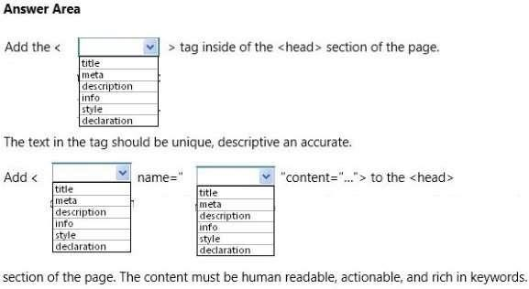

Question 22 (2 points) :

You are developing an ASP.NET MVC application. The application has a view that displays a list of orders in a
multi-select list box.
You need to enable users to select multiple orders and submit them for processing.
What should you do? (To answer, drag the appropriate words to the correct targets. Each word may be used once, more than once, or not at all. You may need to drag the split bar between panes or scroll to view
content.)
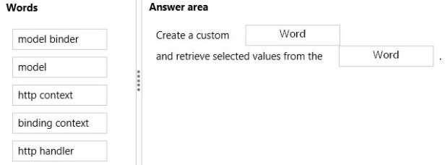Select and Place:

You are developing an ASP.NET MVC application by using Visual Studio. The application throws and handles exceptions when it runs.
You need to examine the state of the application when exceptions are thrown. What should you do?

A.
From the Debug menu in Visual Studio 2012, select Exceptions. Enable the Thrown check box for Common
Language Runtime Exceptions.

B.
From the DEBUG menu in Visual Studio 2012, select Attach to Process. Select the IIS process.

C.
From the Debug menu in Visual Studio 2012, select Exceptions. Disable the User-unhandled check box for
Common Language Runtime Exceptions.

D.
From the TOOLS menu in Visual Studio 2012, click Customize. Click the Command tab and select Debug.

Question 24 (2 points) :

You are designing an HTML5 website.
You need to design the interface such that the content is viewable in all types of browsers, including screen readers.What should you do? (Each correct answer presents a complete solution. Choose all that apply.)

A.
Ensure that content elements have valid and descriptive names.

B.
Use Resource Description Framework (RDF) to describe content elements.

C.
Convert HTML forms to XForms.

D.
Use HTML5 semantic markup elements.

E.
Annotate content elements with Accessible Rich Internet Application (ARIA) attributes.

You are developing an ASP.NET MVC application that will be deployed to servers on multiple networks.
The application must be compatible with multiple browsers. You must track the page number that the user is viewing in search results.
You need to program the location for storing state information.
Where should you persist state information?

A.
Session

B.
QueryString

C.
Application

D.
TempData

Question 26 (1 point) :

You are designing a distributed application that runs on the Microsoft Azure platform.
The application must store a small amount of information that is shared cross all users and does not change frequently.
You need to configure the application to meet the requirements.Which server-side state management option should you use? (Each correct answer presents a complete
solution. Choose all that apply.)

A.
Microsoft Azure application state

B.
SQL Database

C.
Profile properties of the Microsoft Azure application

D.
Microsoft Azure session state

You are developing an ASP.NET MVC application in Visual Studio. The application contains sensitive bank account data.
The application contains a helper class named SensitiveData.Helpers.CustomEncryptor.

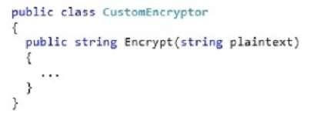

The application contains a controller named BankAccountController with two actions.

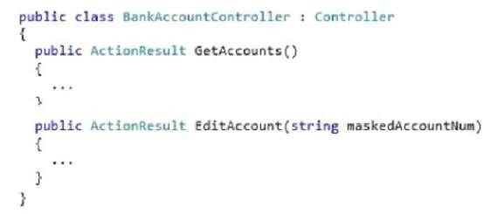

The application contains a model named BankAccount, which is defined in the following code segment.

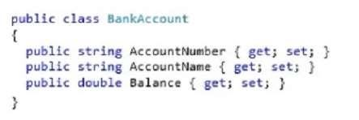

The application must not display AccountNumber in clear text in any URL.
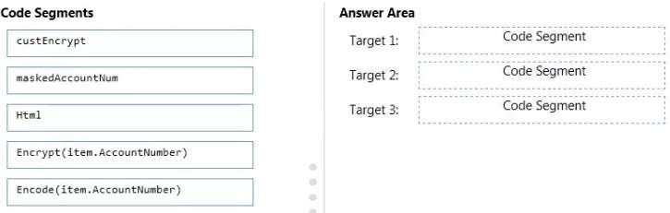You need to build the view for the GetAccounts action. You have the following code:

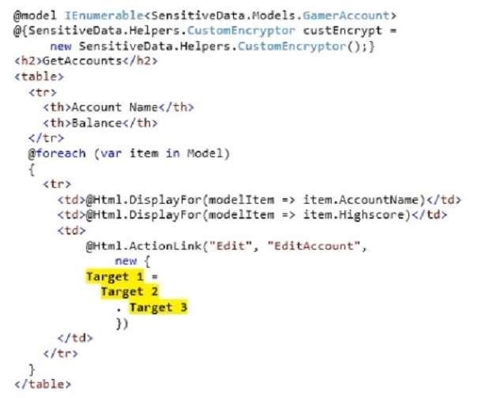

Which code segments should you include in Target 1, Target 2 and Target 3 to build the view? To answer, drag
the appropriate code segment to the correct targets. Each code segment may be used once, more than once, or not at all. You may need to drag the split bar between panes or scroll to view content.
Select and Place:

You are testing an ASP.NET application.
The test plan requires that tests run against the application’s business layer.
You need to use the test project template that meets this requirement. Which template should you use?

A.
Web Test Project

B.
Load Test Project

C.
Unit Test Project

D.
Coded Test Project

You are developing an ASP.NET MVC web application for viewing a photo album. The application is designed for devices that support changes in orientation, such as tablets and smartphones. The application displays a grid of photos in portrait mode.
When the orientation changes to landscape, each tile in the grid expands to include a description. The HTML that creates the gallery interface resembles the following markup.If this CSS is omitted, the existing CSS displays the tiles in landscape mode.

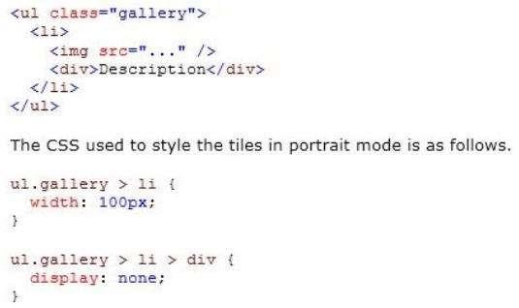

You need to update the portrait mode CSS to apply only to screens with a width less than 500 pixels. Which code segment should you use?

A.
@media resolution(max-width: 500px) {. . .}

B.
@media screen(min-width: Opx, max-width: 500px) {. . .}

C.
@media screen and (width <= 500px) {. . .}

D.
@media screen and (max-width: 500px) {. . .}
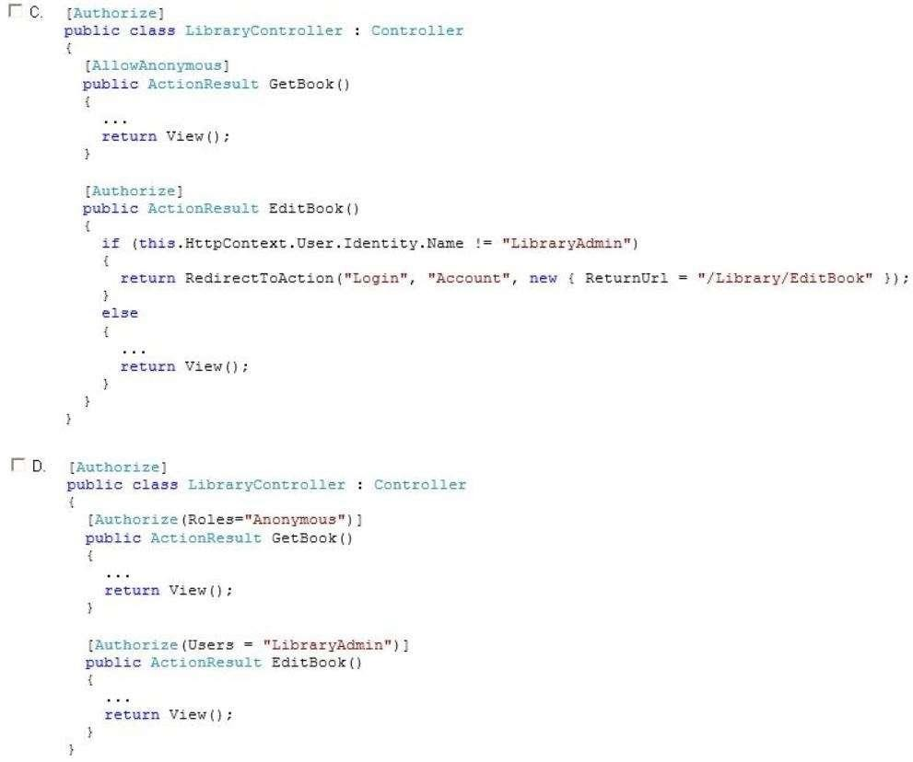Question 30 (2 points) :

You are developing an ASP.NET MVC application that uses forms authentication. The user database contains a user named LibraryAdmin.
You have the following requirements:
You must allow all users to access the GetBook method.
You must restrict access to the EditBook method to the user named LibraryAdmin. You need to implement the controller to meet the requirements.
Which code segment should you use?

(Each correct answer presents a complete solution. Choose all that apply.)
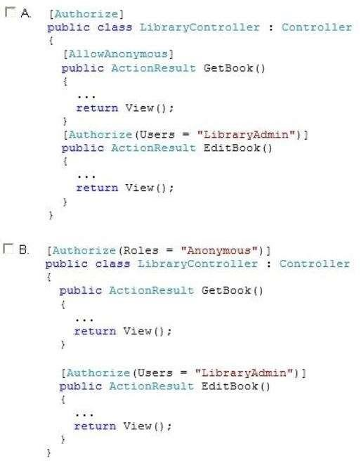

You are developing an online shopping web application.

Business Requirements :

• A user is not required to provide an email address.
• If a user enters an email address, it must be verified to be a valid email address.
• Information about the first product on the product page must fade out over time to encourage the user to continue browsing the catalog.
• Administrators must be able to edit information about existing customers.
• Administrators also must be able to specify a default product on the product page.

Technical Requirements :

General

• The web store application is in a load-balanced web farm.
• The load balancer is not configured to use server affinity.
• The web store application is an ASP.NET MVC application written in Visual Studio.

Products

• The value of the product ID property must always be greater than 0.
• The Products page for mobile devices must display to mobile users.
• The Products page for desktop devices must display to desktop users.

Storage

• The data must be stored in a serialized XML data format.
• Serialized objects must be schema-independent.

Exception handling:

• Exceptions originating from IIS must display a page with support contact information.
• Some page links expire, and users who access these links encounter 404 errors.
• Exceptions must be logged by using the WriteLog method of the Utility class.

Browser and device support:

• The application must support image format conversions from .bmp to .jpeg for mobile devices.
• The application must support image format conversions from .bmp to .png for desktop devices.
Application Structure

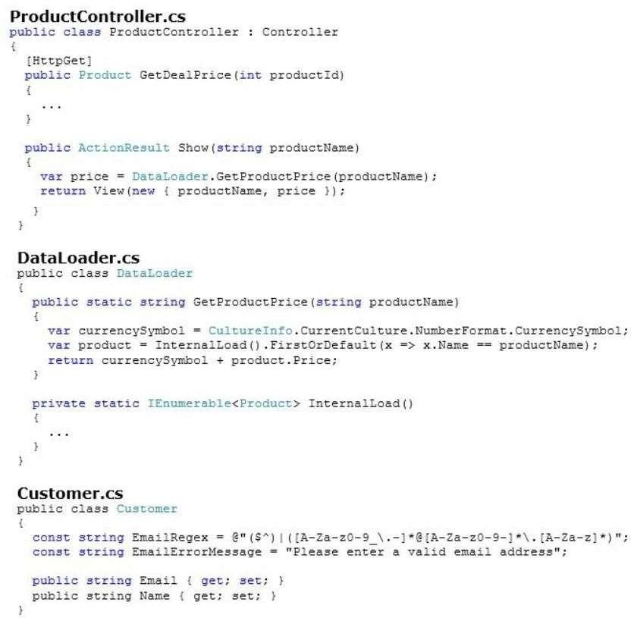

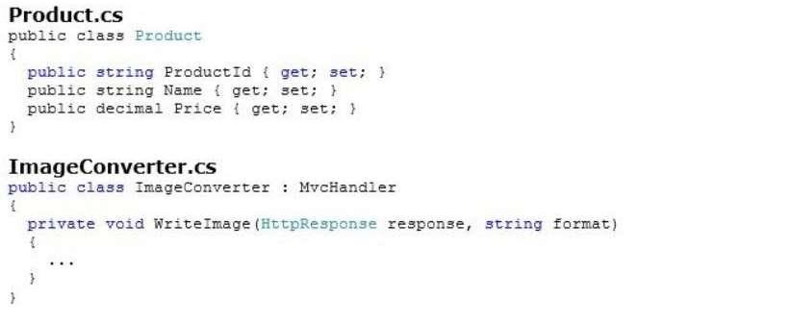

You need to implement the mobile device support requirements.
How should you build the ProcessRequest method? (To answer, select the appropriate options in the answer area.)

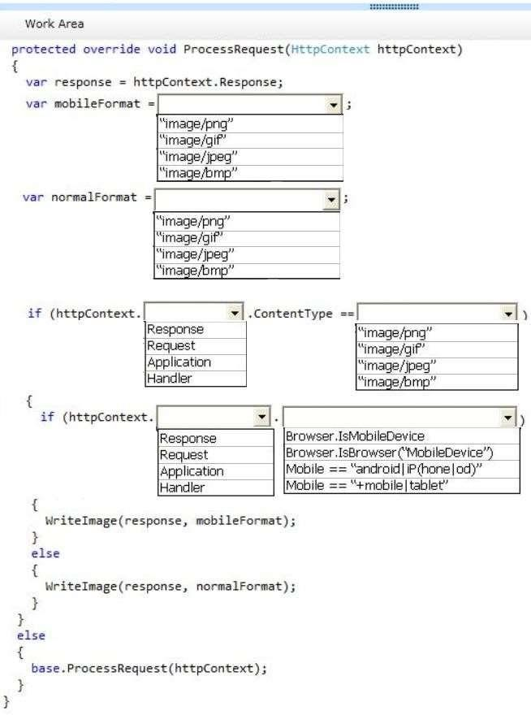

The GetDealPrice method must be called by using Ajax.
You need to get the price of a product by using the GetDealPrice method of the ProductController.
Which code segment should you use? (Each correct answer presents a complete solution. Choose all that apply.)

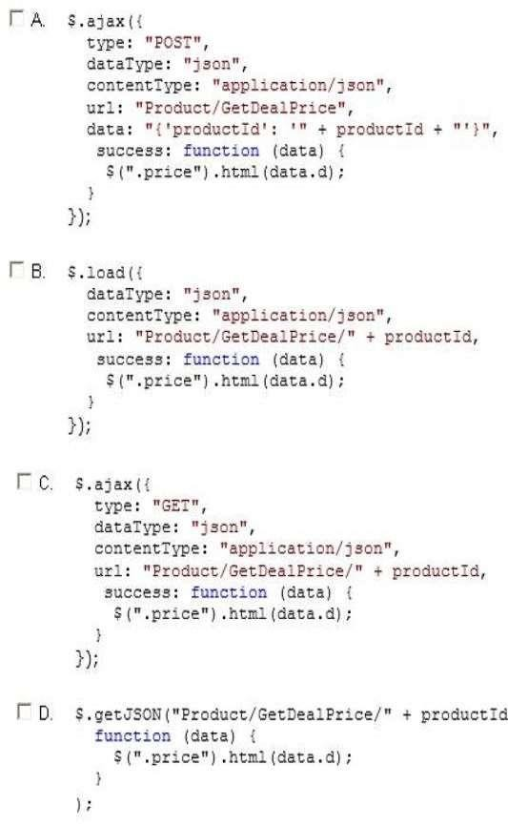

You need to update the routes to ensure that a product is always displayed on the product page. Which code segment should you use?

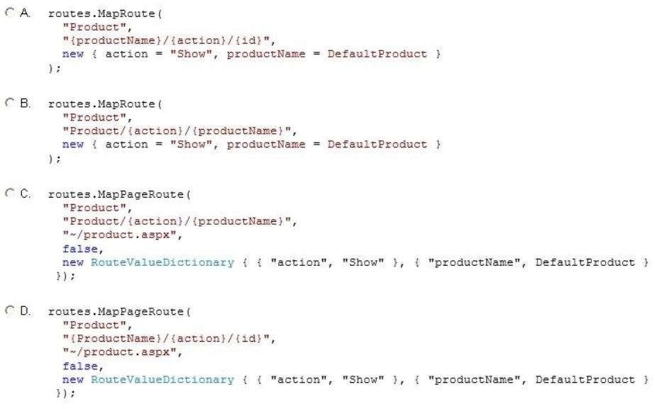

Question D (4 points) :

You need to implement client-side animations according to the business requirements.
Which line of code should you use? (Each correct answer presents a complete solution. Choose all that apply.)

A.
$(“body h1:nth-child(1)”).fadeIn(1000);

B.
$(“body h1:nth-child(1)”).fadeOut(1000);

C.
$(“body h1:nth-child(1)”).animate({ opacity: 0 });

D.
$(“body h1:nth-child(1)”).animate({ opacity: 1 });

When users attempt to retrieve a product from the product page, a run-time exception occurs if the product does not exist.
You need to route the exception to the CustomException.aspx page. Which method should you add to MvcApplication?

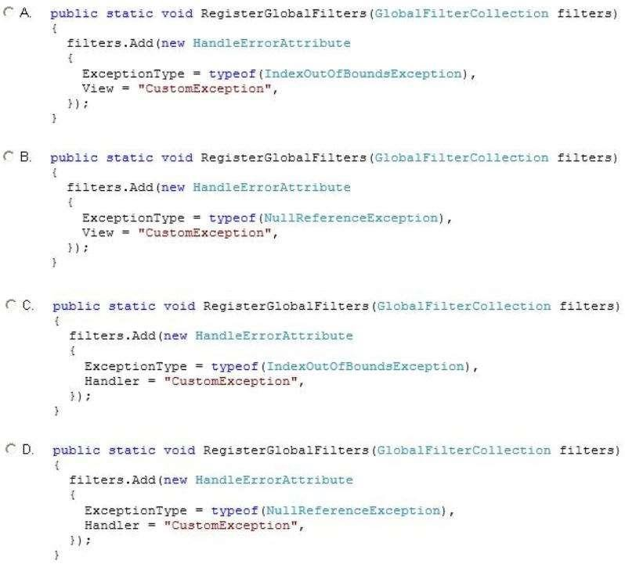

You need to implement the business requirements for managing customer data.
What should you do? Each correct answer presents part of the solution. Choose all that apply.

A.
Add a folder named Customer to the Views folder. Then create a view inside this folder named Edit.aspx.

B.
Add a folder named EditCustomer to the Views folder. Then create a view inside this folder named
Catalog.aspx.

C.
Add a class named CustomerController to the Controllers folder. Then add a method named Edit to theclass.

D.
Add a class named Catalog to the Controllers folder. Then add a method named EditCustomer to the class.

Question G (2 points) :

You need to modify the application to meet the product Id requirement. What should you do?

A.
Modify the RegisterGlobalFilters method of the Global.asax.cs file as follows. Contract.Assume<ArgumentException>(productId != 0);
B.
Modify the GetDealPrice method of ProductController as follows. Contract.Requires<ArgumentException>(productId > 0);
C.
Modify the RegisterGlobalFilters method of the Global.asax.cs file as follows. Contract.Requires<ArgumentException>(productId > 0);
D.
Modify the GetDealPrice method of ProductController as follows. Contract.Assume<ArgumentException>(productId != 0);

You need to add a method to the ProductController class to meet the exception handling requirements for logging.
Which code segment should you use?

